**ECR and ECR POC**

* **Create an EC2 instance and build image of any application using Docker**

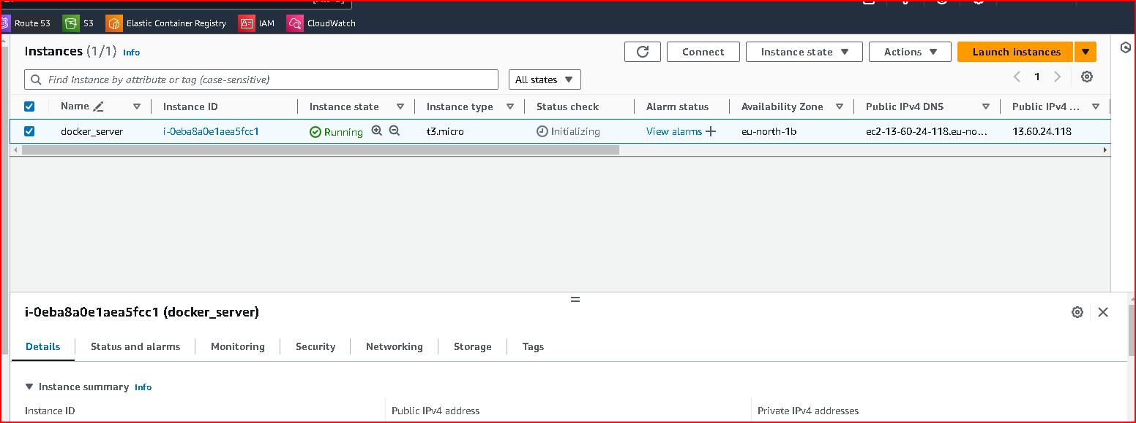

sudo apt update

sudo apt install apt-transport-https ca-certificates curl software-properties-common

curl -fsSL https://download.docker.com/linux/ubuntu/gpg | sudo apt-key add –

sudo add-apt-repository "deb [arch=amd64] https://download.docker.com/linux/ubuntu $(lsb_release -cs) stable"

sudo apt update

sudo apt install docker-ce

clone github repo : <https://github.com/rushikeshmj/webapp.git>

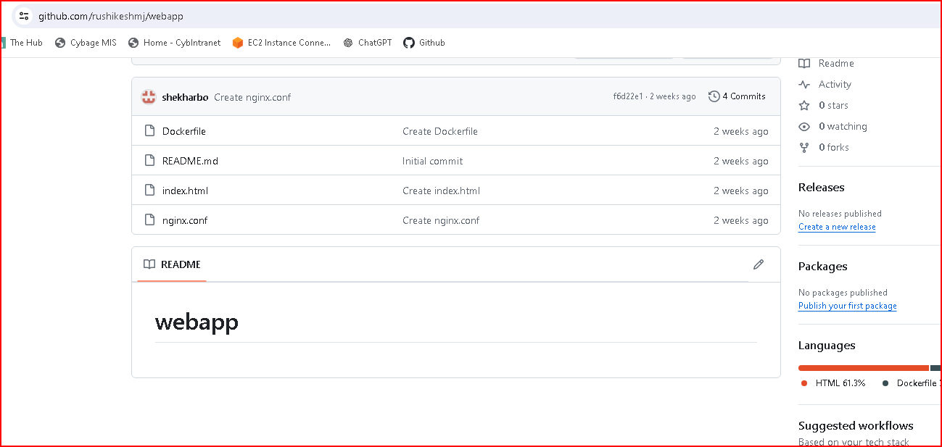

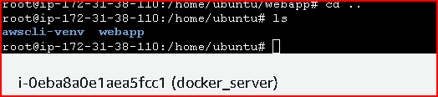

**Build docker image in local**

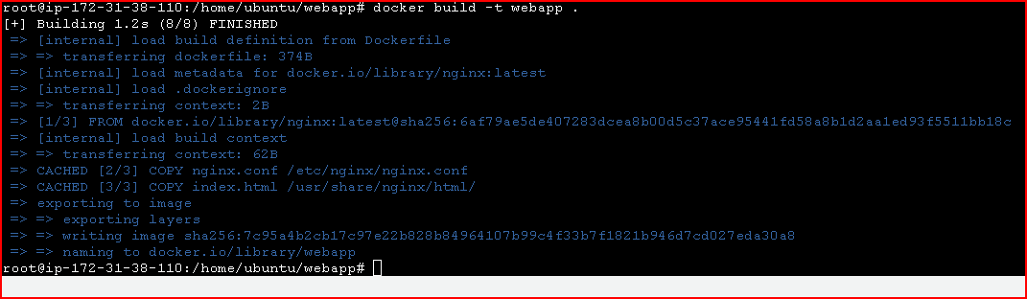

**Create a private ECR repo and push this docker image to ECR repo**

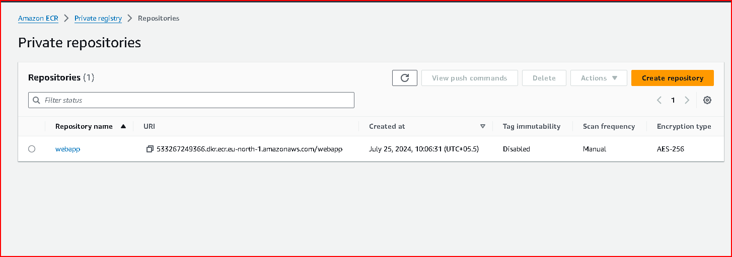

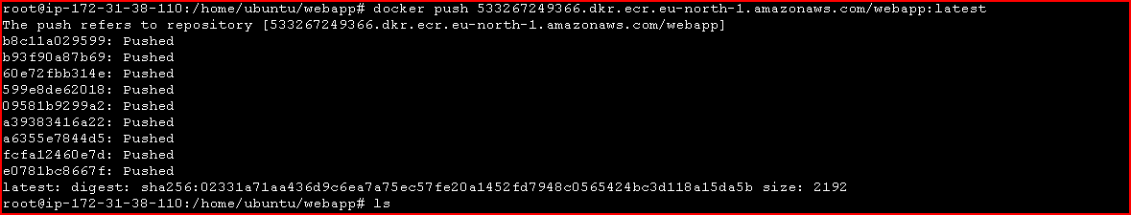

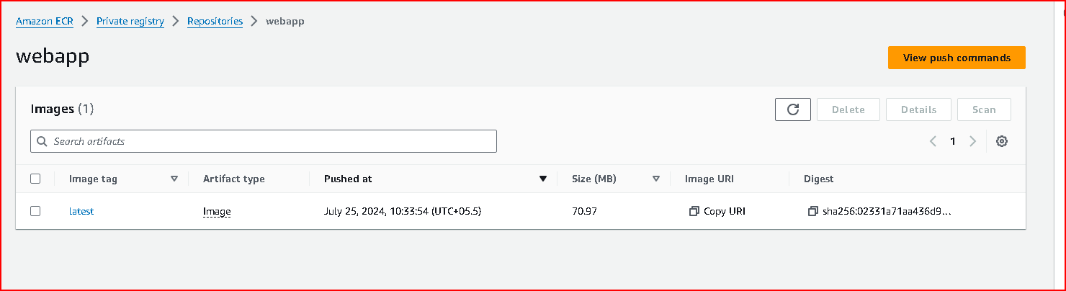

* **Deploy the application on ECS and check if the application works fine**

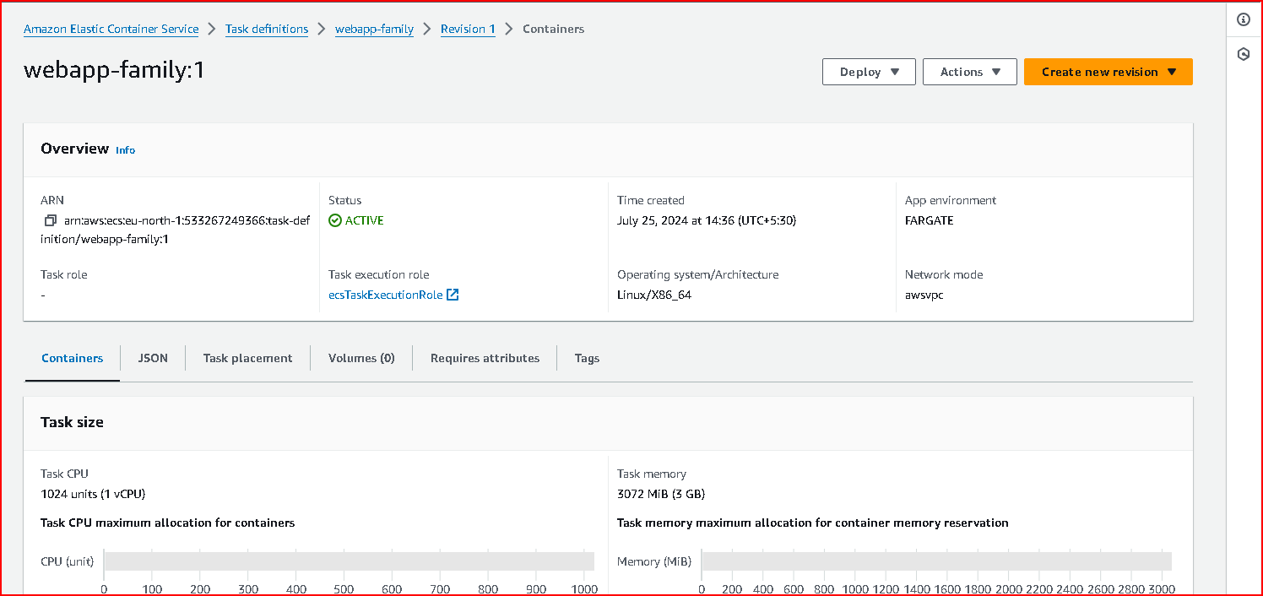

Create cluster :

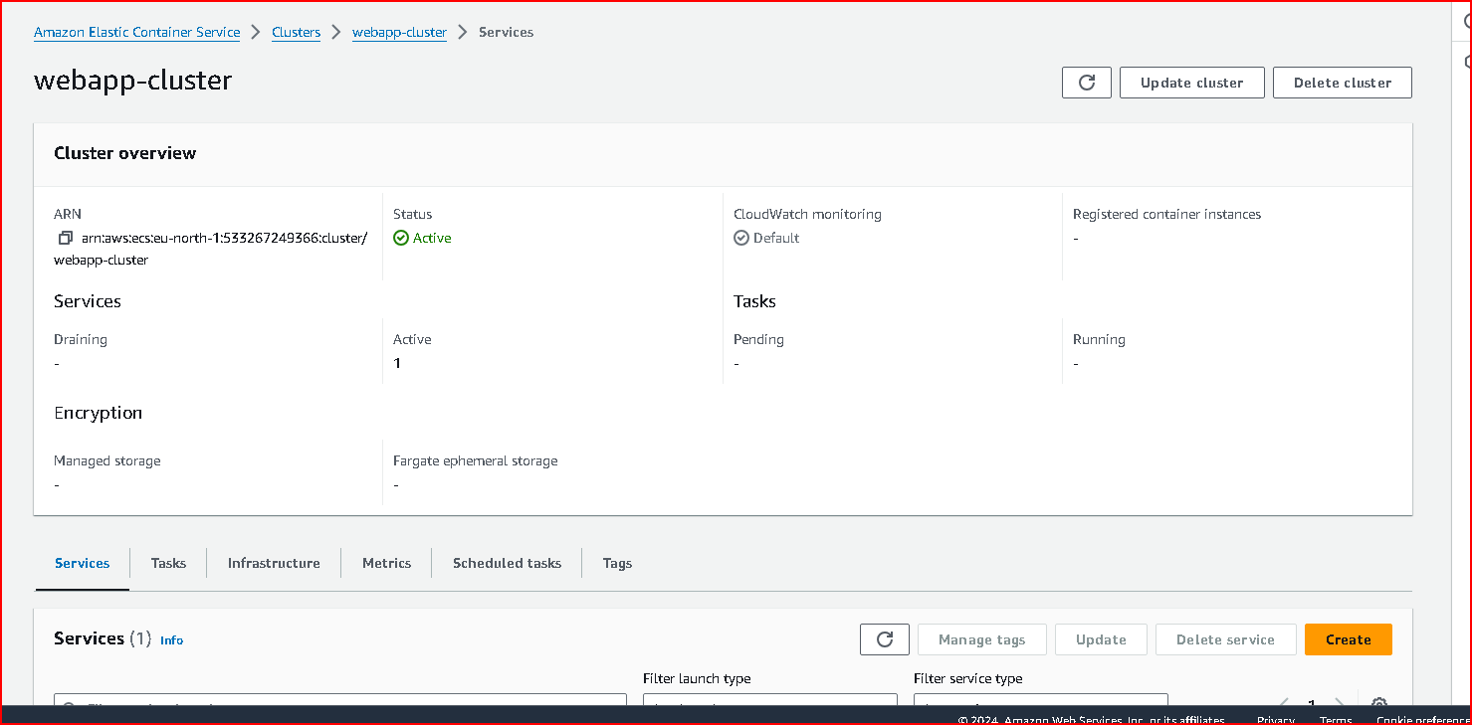

Create service :

